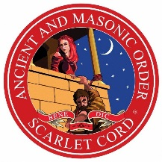

**The Ancient and Masonic Order of the Scarlet Cord**

**in the British Isles and its Districts and Consistories Overseas**

**TOAST LIST**

**After Grace**

THE KING

***

Most Distinguished Companion Ian Stanley Currans, VI

GRAND SUMMUS

***

Right Distinguished Companion Francis Charles Spencer, VI

DEPUTY GRAND SUMMUS

Right Distinguished Companion Howard Saul Markham, VI

ASSISTANT GRAND SUMMUS

and the rest of the Grand Officers, present and past

***

Right Distinguished Companion Terence Douglas Sheern V

PROVINCIAL GRAND SUMMUS

***

Distinguished Companion David Ernest Atterbury IV, Grand Steward.

DEPUTY PROVINCIAL GRAND SUMMUS

Distinguished Companion Trevor Dixon Armstrong III

ASSISTANT PROVINCIAL GRAND SUMMUS

and the rest of the Provincial Officers, present and past

***

The President

***

The Candidate(s)*

(on first entry into the Order)

***

The Visitors*

* When applicable